Initialization strategies

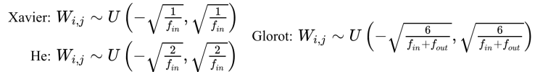

● Most strategies:
○ Are simple and heuristic
○ Try to achieve nice properties during initialization
○ We don’t know if the nice properties are preserved during training
○ We don’t know how initialization affects generalization
● Some tips:
○ We don’t want weights with the same values
■ Random initialization using a Gaussian or a uniform distribution
○ Large values may lead to exploding or vanishing gradients

Documentation: https://docs.pytorch.org/docs/2.12/nn.init.html

